SIMATS ENGINEERING
CO3 - ASSESSMENT TOOL - 2: Case Study

COURSE NAME: Cloud Computing and COURSE CODE: CSA1507
Big Data Analytics

Name | Harsita Ashok
Register Number | 192521086

COURSE OUTCOME COVERED
CO3: Implement cloud-based solutions using cloud storage, web APIs, and platform services for real-world applications. (BL3)

Dave's Taxonomy: Precision (Level 3) Total Marks: 30
Question Count: 3

Code of Conduct
I Harsita Ashok-192521086 certify that this submission is my original work and that I have adhered to the guidelines specified for this assessment.
I understand that any violation of academic integrity rules will result in disciplinary action. Signature of the student: Harsita Ashok

Assessment Tasks - Case Study 1. Case Study 1: Smart Retail Inventory Management System

A retail chain implements a cloud-based inventory system connected to store devices. Clients (POS systems and dashboards) communicate via APIs to centralized cloud services. Cloud storage stores product data, transaction logs, and analytics datasets. The system uses platform services for analytics and demand forecasting. Secure access is maintained through VPNs, firewalls, and API gateways. This solution integrates infrastructure, services, and web applications for efficient operations.

2. Case Study 2: Cloud-Based Document Collaboration System

An enterprise deploys a document collaboration tool similar to Google Docs. Users access the platform via browsers, enabling real-time editing and sharing. Documents are stored in distributed cloud storage with version control mechanisms. Web APIs enable synchronization across multiple clients and devices.
Network infrastructure ensures low latency and high availability globally. Security includes encryption, identity management, and access permissions for collaboration.

3. Case Study 3: Online Food Ordering Platform
A startup builds a cloud-based food ordering system accessible via web browsers and mobile clients.
Frontend clients interact with backend services through RESTful Web APIs hosted on a cloud platform.
Cloud storage is used to store menu images, invoices, and customer data securely. The infrastructure uses virtual machines and managed Kubernetes for scalability and reliability. Security is enforced through authentication tokens, HTTPS, and role-based access control. The system demonstrates integration of clients, APIs, storage, and platform services in real time.

Case Study Rubric
Criteria | Weightage | Level 4 -  Exemplary | Level 3 -  Proficient | Level 2 -  Developing | Level 1 -  Beginning
Understanding of Case | 25% | Clearly identifies all technical and business requirements | Identifies most requirements | Basic understanding only | Poor understanding of case
Application of Concepts | 25% | Applies suitable cloud concepts and tools effectively | Good  application with minor issues | Partial application | Weak or incorrect application
Analysis | 20% | Strong analysis with clear trade-off reasoning | Reasonable analysis | Limited analysis | Minimal analysis
Solution Design | 20% | Solution is feasible, practical, and well justified | Reasonable solution with minor gaps | Basic solution | Unclear solution
Clarity | 10% | Wellstructured and easy to follow | Mostly clear | Somewhat unclear | Poorly organized

Case Study 1: Smart Retail Inventory Management System
A retail chain implements a cloud-based inventory system connected to store devices. Clients (POS systems and dashboards) communicate via APIs to centralized cloud services. Cloud storage stores product data, transaction logs, and analytics datasets. The system uses platform services for analytics and demand forecasting. Secure access is maintained through VPNs, firewalls, and API gateways. This solution integrates infrastructure, services, and web applications for efficient operations.

1. Understanding of the Case
The retail chain requires a cloud-based inventory management system that connects multiple stores through centralized cloud services. The system should:
- Manage inventory across all stores.
- Connect POS systems and management dashboards.
- Store product information and transaction records securely.
- Perform demand forecasting using cloud analytics.
- Provide secure communication using VPN, Firewall, and API Gateway.
- Offer high availability and scalability.
2. Application of Cloud Concepts

Cloud Service Models
Service | Purpose
IaaS | Virtual machines for backend inventory services
PaaS | Analytics platform and demand forecasting
SaaS | Web dashboard for store managers

Cloud Components
- POS terminals (Client)
- Management Dashboard
- REST APIs
- API Gateway
- Cloud Database
- Cloud Storage
- Analytics Platform
- Demand Forecasting Service
- VPN
- Firewall
- Load Balancer
3. Analysis

Advantages
- Centralized inventory across all branches
- Real-time stock updates
- Accurate demand prediction
- Reduced manual inventory errors
- Easy expansion to new stores

Challenges
- Internet dependency
- Cloud service cost
- Data security
- API latency

Trade-offs

Choice | Benefit | Limitation
Centralized Database | Consistent inventory | Higher network dependency
Cloud Analytics | Better forecasting | Additional processing cost
API Gateway | Improved security | Slight latency

4. Solution Design


POS

Systems

API

Gateway

Load

Balancer

Inventory

Services

Cloud

Storage

Analytics

Platform

Demand

Forecasting

Manager

Dashboard

Security
- VPN
- Firewall
- HTTPS
- API Authentication
- Role-Based Access Control (RBAC)

5. Conclusion
The proposed architecture provides centralized inventory management, real-time updates, scalable cloud infrastructure, and secure communication while enabling analytics-driven business decisions.

Case Study 2: Cloud-Based Document Collaboration System
An enterprise deploys a document collaboration tool similar to Google Docs. Users access the platform via browsers, enabling real-time editing and sharing. Documents are stored in distributed cloud storage with version control mechanisms. Web APIs enable synchronization across multiple clients and devices.
Network infrastructure ensures low latency and high availability globally. Security includes encryption, identity management, and access permissions for collaboration.

1. Understanding of the Case
The enterprise requires an online document collaboration platform that enables:
- Real-time editing
- Document sharing
- Version control
- Synchronization across devices
- Global availability
- Secure collaboration
2. Application of Cloud Concepts

Cloud Service Models
Service | Purpose
SaaS | Document editing application
PaaS | Collaboration engine
IaaS | Compute instances for backend processing

Components
- Web Browser
- Mobile Client
- REST/WebSocket APIs
- Collaboration Server
- Distributed Cloud Storage
- Version Control
- Identity Management
- Load Balancer

Analysis

Advantages
- Simultaneous editing
- Automatic saving
- Version history
- Access from anywhere
- High availability

Challenges
- Conflict resolution
- Data synchronization
- Large storage requirements
- Security threats

Trade-offs

Choice | Benefit | Limitation
Distributed Storage | High availability | More complex management
Real-time Sync | Better collaboration | Increased network usage
Encryption | Better security | Small performance overhead

Solution Design


Users

Browser

/

Mobile

App

API

Gateway

Collaboration

Server

Version

Control

Distributed

Storage

Synchronization

Security
- HTTPS
- Identity Management
- Access Permissions
- Encryption at Rest
- Encryption in Transit
- Multi-Factor Authentication Conclusion
The cloud-based collaboration system enables secure, scalable, and highly available document editing with efficient synchronization and reliable version control.
Case Study 3: Online Food Ordering Platform

1. Understanding of the Case
The startup requires an online food ordering platform supporting:
- Mobile and web clients
- RESTful APIs
- Cloud storage
- Scalable backend
- Secure payments
- Reliable infrastructure
2. Application of Cloud Concepts
Cloud Service Models

Service Purpose

IaaS Virtual Machines
PaaS Managed Kubernetes
SaaS Food ordering web application

Components
- Mobile App
- Web Browser
- REST APIs
- API Gateway
- Kubernetes Cluster
- Cloud Storage

- Database
- Authentication Server
- Payment Service 3. Analysis

Advantages
- Supports thousands of users
- Easy deployment
- High scalability
- Fault tolerance
- Secure transactions

Challenges
- Traffic spikes
- Payment security
- Storage management
- Service monitoring

Trade-offs

Choice | Benefit | Limitation
Kubernetes | Automatic scaling | Higher management complexity
Cloud Storage | Secure file storage | Storage cost
REST APIs | Easy integration | Stateless communication

4. Solution Design

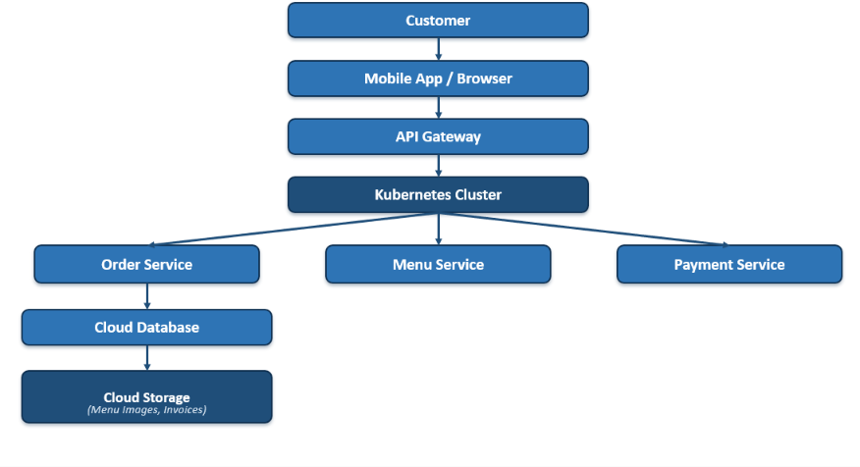

Security
- HTTPS
- JWT Authentication Tokens
- Role-Based Access Control (RBAC)
- OAuth Authentication
- Firewall
- API Gateway

5. Conclusion
The proposed architecture provides a scalable, secure, and highly available food ordering platform capable of handling real-time customer requests while maintaining data security and efficient cloud resource utilization.

